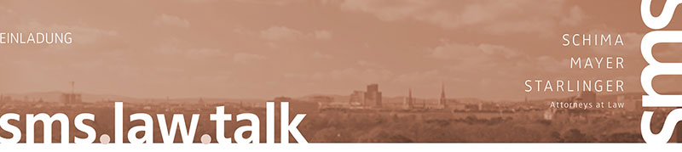

**IS ISDS FIT FOR PURPOSE? –**

**Investor State Dispute Settlement now and next**

the Forum for International Conciliation and Arbitration ([*www.fica-disputeresolution.com*](http://www.fica-disputeresolution.com))

together with

SMS Schima Mayer Starlinger Attorneys-at-Law ([*www.sms.law*](http://www.sms.law))

are happy to host a lecture and subsequent panel discussion

**16 APRIL 2019, 4:30 p.m.**

SMS ATTORNEYS AT LAW, 1020 VIENNA, Trabrennstrasse 2B, 7. OG

**AGENDA**

4:30 p.m. *-* REGISTRATION

4.45 p.m. – KEY Note, *isds – The Uncitral View*’  
Dr Timothy Lemay, FCIArb, DR Advisor, FICA Vice Chair

5:15 p.m. – PANEL DISCUSSION

* Ben Beaumont, CArb, FICA Chair, Garden Court Chambers
* Dr Alan Anderson, FCIArb, FICA Secretary Alan Anderson Law Firm LLC, Minneapolis, USA, Littleton Chambers
* Dr Georg Adler, WilmerHale, London
* Constantin Eschlböck, FCIArb, FICA Managing Director, Schima Mayer Starlinger, Vienna

6:00 p.m. – Reception (drinks and snacks)

**REGISTRATION**

RSVP before 9 April 2019 to [talk@sms.law](mailto:talk@sms.law)

*We maintain your email address based on our business relationships in our database and believe that this information event may be of interest to you. If you do not wish to receive any invitations or information about such events, we kindly ask for an informal reply to the following e-mail address: unsubscribe@sms.law. In accordance with the requirements of the GDPR, we would like to point out that you can delete yourself at any time from our e-mail distribution list.*



FORUM FOR INTERNATIONAL CONCILIATION AND ARBITRATION

www.fica-disputeresolution.com

FICA